**UNIVERSITY OF INFORMATION AND TECHNOLOGY**

**THE FACULTY OF SOFTWARE ENGINEERING**



**[APPLICATION FOR DISCOVERY SOCIAL MEDIA – AHIHI APP]**

**SOFTWARE ARCHITECTURE DESIGN**

|  |  |
| --- | --- |
|  | Author: Nguyen Van Dat |
|  | Assessor: Mr. Nguyen Trinh Dong |

Lam Dong City, 11th December 2021

**Contents**

I. Introduction 7

1. Purpose 8

2. Scope 8

3. Definitions, Acronyms, and Abbreviations 9

4. System Overview 9

II. Architectural Representation 9

1. Scenarios 9

2. Logical View 10

3. Process View 10

4. Deployment View 11

5. Physical View 11

III. Architectural Goals and Constraints 11

1. User side 11

2. Backend Side 11

3. Security 12

4. Persistence 12

5. Reliability / Availability 12

6. Performance 13

7. Portability and Reuse 13

8. Development Tools 13

9. Workflow 14

IV. Use-Case View 15

1. Use case diagrams 15

2. Use-Case Realizations 16

2.1 User Roles 16

2.1.1 Login 16

2.1.2 Login by APIs 17

2.1.3 Forgot Password 18

2.1.4 Register 19

2.1.5 Search 20

2.1.6 Write Post 20

2.1.7 Write Comment 21

2.1.8 Like 22

2.1.9 Dislike 22

2.1.10 Report 23

2.1.11 Chat 24

2.1.12 Book Services 25

2.1.13 Watch News 26

2.1.14 Block News 26

2.1.15 Add Friend 27

2.1.16 Delete Friend 28

2.1.17 View Friend List 28

2.1.18 Change Password 29

2.1.19 Lock Account 30

2.1.20 Change Account Information 31

2.1.21 Help 31

2.1.22 Create Page 32

2.1.23 Create Group 33

2.1.24 Switch Page/Group 34

2.1.25 Notify 34

2.1.26 View Ranking List 35

2.2 Page Roles 36

2.2.1 Add Admin 36

2.2.2 Delete Admin 36

2.2.3 Get Admin List 37

2.2.4 Lock Page 38

2.2.5 Delete Page 39

2.2.6 Edit Page 39

2.2.7 Register ADS 40

2.2.8 View ADS History 41

2.2.9 Cancel ADS 42

2.2.10 Add Services 42

2.3 Group Roles 43

2.3.1 Add Admin 43

2.3.2 Delete Admin 44

2.3.3 Get Admin List 45

2.3.4 Add Member 45

2.3.5 Delete Member 46

2.3.6 Get Member List 47

2.3.7 Lock Group 48

2.3.8 Delete Group 48

2.3.9 Edit Group 49

V. Logical View 50

1. Overview 50

1.1 Subsystems 50

1.1.1 Ranking. 50

1.1.2 ADS management. 51

1.1.3 Account. 51

1.1.4 New Feeds. 52

1.1.5 Services. 52

1.1.6 Group/Page. 52

1.2 Layering 53

VI. Process View 54

1. Sequence Diagrams 54

1.1 Register 54

1.2 Login 56

1.3 Login by APIs 57

1.4 Forgot Password 58

1.5 Change Password 59

1.6 Write Post 59

1.7 Comment 60

1.8 Like 60

1.9 Dislike 60

1.10 Watch Notification List 61

1.11 Report 61

1.12 Watch News 62

1.13 Block News 62

1.14 Add Friends 63

1.15 Create Page 63

1.16 Create Group 64

1.17 Add Services 65

1.18 Switch Page/Group 66

1.19 Add Admin 66

1.20 Delete Admin 67

1.21 Add Member 67

1.22 Delete Member 68

1.23 Register ADS 68

1.24 Cancel ADS 69

2. Activity Diagrams 69

2.1 User Roles 69

2.1.1 Login 69

2.1.2 Login by APIs 70

2.1.3 Forgot Password 70

2.1.4 Register 70

2.1.5 Search 71

2.1.6 Write Post 71

2.1.7 Write Comment 72

2.1.8 Like 72

2.1.9 Dislike 73

2.1.10 Report 73

2.1.11 Chat 74

2.1.12 Book Services 74

2.1.13 Watch News 74

2.1.14 Block News 75

2.1.15 Add Friend 75

2.1.16 Delete Friend 76

2.1.17 View Friend List 76

2.1.18 Change Password 77

2.1.19 Lock Account 77

2.1.20 Change Account Information 77

2.1.21 Help 78

2.1.22 Create Page 78

2.1.23 Create Group 79

2.1.24 Switch Page/Group 79

2.1.25 Notify 79

2.1.26 View Ranking List 80

2.2 Page Roles 80

2.2.1 Add Admin 80

2.2.2 Delete Admin 80

2.2.3 Get Admin List 81

2.2.4 Lock Page 81

2.2.5 Delete Page 81

2.2.6 Edit Page 82

2.2.7 Register ADS 82

2.2.8 View ADS History 83

2.2.9 Cancel ADS 83

2.2.10 Add Services 84

2.3 Group Roles 84

2.3.1 Add Admin 84

2.3.2 Delete Admin 85

2.3.3 Get Admin List 85

2.3.4 Lock Group 85

2.3.5 Delete Group 86

2.3.6 Edit Group 86

2.3.7 Add Member 87

2.3.8 Delete Member 87

2.3.9 Get Member List 88

VII. Deployment View 88

VIII. Implementation View 89

1. Overview 89

2. Module Diagram 91

IX. Data View 91

1. ER Diagram 91

X. Size and Performance 92

XI. Quality 93

# Introduction

**AHIHI** is an app use for 2 main kinds of users : Customer – who have traveled or want to travel and Agency – Who provides local services like product or others travel services. Ahihi provide basic function for normal user and tool for stack holder analyze data from database to make links to Tourist-Tourist, Tourist-Agency and Agency-Agency throughout an account that can manage almost function in Ahihi, and friendly UI for user, easy to use.

This document describes in detail the software architecture of the “Ahihi App”. Document layout is written in the form of 4+1. The system architecture is divided into many modules and components for ease of development, monitoring, and maintenance, which will be discussed in detail below.

## Purpose

This document provides a comprehensive architectural of the system, using several different architectural views to depict aspects of the system. It is intended to capture and convey the significant architecture decisions which have been made on the system.

This document elaborates the architecture of the system in 5 different views (4+1 view model). Both static and dynamic behavior of the system is described in this document. All the requirement diagrams and their descriptions are available in this document.

## Scope

This software architecture document provides an overview of the Ahihi app that can connect Tourist-Tourist, Tourist-Agency and Agency-Agency. The document was written by the system development team based on the sample SAD document.

## Definitions, Acronyms, and Abbreviations

|  |  |
| --- | --- |
| **Glossary** | **Description** |
| User | Who will register account an use the web with UI and function for customer |
| User roles | Basic roles that provide basic function |
| Page roles | Administrator roles in Page |
| Group roles | Administrator roles in Group |
| Agents | Who can provide APIs or get data from Ahihi |
| Group | A group of community hold by users |
| Page | A page have detail of an local Place/Company that have services |

DB – Database

## System Overview

The report will present a detailed analysis of the architecture of Ahihi. Further sections cover the architectural representation of the project including architectural representation, architectural goals and constraints and use case realizations. The later sections cover the detailed specific details of 4 main views (logical view, process view, deployment view, implementation view) of the system. Furthermore, the document describes the data view and performance, quality views.

# Architectural Representation

This section details the architecture using the views defines in the “4+1” view model. The views used to document the Ahihi application are:

## Scenarios

**Audience:**

All the stakeholders of the system, including the end-users.

**Area:**

Describes the set of scenarios and/or use cases that represent some significant, central functionality of the system. Describes the actors and use cases for the system. Other than the basic work flows the documents addresses the exception cases, exception outputs, and other related use cases.

## Logical View

**Audience:**

Designers, Programmers, Testers

**Area:**

Functional requirements, object hierarchy, system layers

Describes the design of object model. Also describes the subsystems of the system and their relationships.

## Process View

**Audience:**

Integrators, Programmers

**Area:**

Non-functional requirements, describes the design’s concurrency and synchronization aspects. Elaborates the run time behavior of the system.

## Deployment View

**Audience:**

Programmers, Testers

**Area:**

Software components: describes the modules and subsystem divisions of the system.

## Physical View

**Audience:**

Database administrators, System engineers, Deployment managers

**Area:**

Databases, data models. The hardware and the association with the software.

# Architectural Goals and Constraints

## User side

**+ Website:** Will be hosted at GCP server so all web users can access with common Web browsers, and have high performance.

**+ Mobile:** Android and IOS operating system so it can easily access almost all users using mobile.

## Backend Side

Ensure stable running and good load when the incoming traffic spikes, but still must ensure system costs.

Ahihi backend using Microservices architecture will be deployed on GCP built-in services such as:

+ Basis load balancer to balance the load between servers

+ CSR management to manage all APIs and communication between services including API gateway and WebSocket Handler

+ GCP Cloud front to CND Media

+ Memcached for catching data

## Security

Sever attack security is handled by the GCP system

Critical APIs must be protected with JWT (JSON Web Token) for authorization and authentication. Access tokens and refresh tokens must have a reasonable expiration time, depending on the importance of the tokens. There should be a mechanism to invalidate the token if it is suspected to be lost by the system

## Persistence

The system's data is stored in two main data types; Mongo DB and MySQL. Databases must ensure safety (minimize data loss) and confidentiality to ensure maximum customer data security.

The system of deploying MySQL servers on the AWS S3 platform provides high security and builds back up databases to serve a large number of users in several modules such as products and orders.

## Reliability / Availability

The system will be subjected to several testing operations (Unit testing, integration testing, system testing) before being deployed to make sure that the system is reliable Backend and database need to achieve high availability, despite the spike in user numbers at times.

## Performance

Performance The system needs to achieve high performance. For simple data reading operations, the response speed must be less than it, for complex data (videos, images) it is necessary to apply paging and optimization mechanisms to ensure the loading speed of information. The important message in less than 3 seconds. Write and update operations should be guaranteed to have low latency depending on the module.

## Portability and Reuse

The system should be able to be reused by properly separating modules. To maintain reusability, all the functionalities are very well structured and layered

## Development Tools

The project incorporates many development tools.

IDE: IntelliJ IDEA

Diagrams: Draw.IO

Database: MySQL

Management software : Microsoft Excel, Notion

Schedule: Microsoft Project

## Workflow

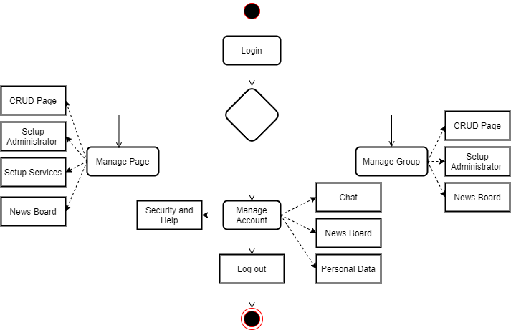

Figure Workflow

# Use-Case View

## Use case diagrams

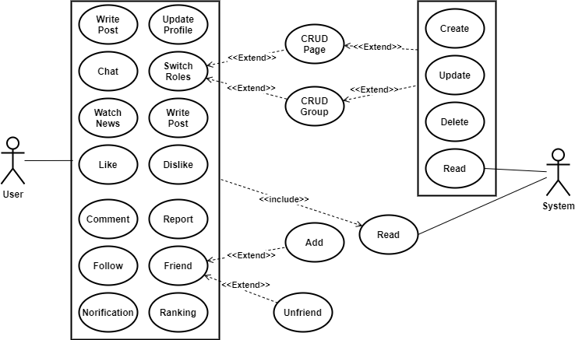

Figure User role Use Case

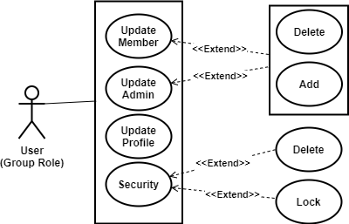

Figure Group Role Use Case

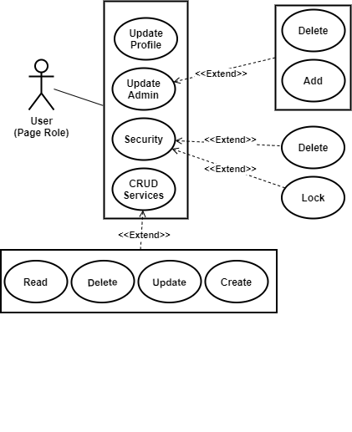

Figure Page role Use Case

## Use-Case Realizations

### 2.1 User Roles

#### 2.1.1 Login

|  |  |
| --- | --- |
| Use case name | Login. |
| Scenario | Login to the system using username and password. |
| Triggering event | User enters the username and password and submit by click button “Login”. |
| Brief description | When user inputs username and password, system checks for the validity and matching of input values and redirects to the home screen of user. |
| Actors | User |
| Related use cases | None. |
| Preconditions | Account that User use must be valid (about username and password). |
| Post conditions | User logged into the system, system redirect User to Home Screen as User role. |
| Flow of events | * Application load Login Screen * User inputs username and password and submit. * System checks the validity of the username and password. * If this is valid user, the user will get redirected to respective home screen. |
| Exception conditions | If the username and password is invalid, error dialog will appear, user will be asked to enter them again. |

#### 2.1.2 Login by APIs

|  |  |
| --- | --- |
| Use case name | Login by APIs. |
| Scenario | Login to the system using APIs method. |
| Triggering event | User enters the username and password and submit by click button “Google” or “Facebook” |
| Brief description | When User click “Google” or “Facebook” button, system will redirect user to API’s Login Screen. User will login by using API’s method |
| Actors | User |
| Related use cases | None. |
| Preconditions | Users have account of API User choose |
| Post conditions | User logged into the system, system redirect User to Home Screen as User role. |
| Flow of events | * Application load Login Screen * User click “Google” button * User choose their account of APIs. Meanwhile system get account data from APIs * If account is existed in system, create new account base on that data then log in as a normal account. Else, log in as a normal account |
| Exception conditions | If APIs return null or exception, display error message and force user login again. |

#### 2.1.3 Forgot Password

|  |  |
| --- | --- |
| Use case name | User log in the system. |
| Scenario | Login to the system using username and password. |
| Triggering event | User click “Forgot Password” button. |
| Brief description | When Users click “Forgot Password” button, system will redirect to “Forgot Password” screen for Users to help they get their password. |
| Actors | User |
| Related use cases | None. |
| Preconditions | The user Account is existed in database |
| Post conditions | New password updated to database. |
| Flow of events | * Application load Forgot Password * User inputs email into “Mail” text box. * System validate User’s email. Then, send “Get Password URL” by mail * User click on “Get Password URL”. * System show “Reset Password” screen * User inputs new password into “New Password” text box and click confirm * System save new password to database and redirect User into “Login” screen |
| Exception conditions | * If email does not exist, show error message and force User inputs email again. * If new password is not correct format, show error message and force User inputs again * If User does not click on “Confirm” button after inputs new password, there will be nothing change in database |

#### 2.1.4 Register

|  |  |
| --- | --- |
| Use case name | Register. |
| Scenario | Register an account in Ahihi app. |
| Triggering event | User click “Register” button. |
| Brief description | When user click “Register” button. System redirect User into “Register” screen to help User register an account |
| Actors | User |
| Related use cases | None. |
| Preconditions | None |
| Post conditions | Account database updated |
| Flow of events | * Application load “Register” Screen * User inputs follow register form and click “Confirm” button. * System validate form then send confirm email. * User click on URL in confirm email, system will allows user log in into application. |
| Exception conditions | * If inputs form is not correct format, show error message and force User input again * If User does not click on URL in confirm email in 30 minutes, system will not allow user log in into system |

#### 2.1.5 Search

|  |  |
| --- | --- |
| Use case name | Search. |
| Scenario | Search data in Ahihi app |
| Triggering event | User click “Search” button |
| Brief description | When user click “Search” button, a Text box will appear for User to search another user or anything that relate to search input. |
| Actors | User |
| Related use cases | News, view friends list, view page/group. |
| Preconditions | User logged into the system |
| Post conditions | Search data display to user |
| Flow of events | * Application load Search Screen * User inputs information that needs search submit. * System search data, show it to user. |
| Exception conditions | If data not exist, show error message and ask User inputs again |

#### 2.1.6 Write Post

|  |  |
| --- | --- |
| Use case name | Write Post. |
| Scenario | Write Post for News Feeds |
| Triggering event | User enters the Post by click button “Post”. |
| Brief description | When user inputs post and submit, system save to database, update New Feeds and notify User’s Friend. |
| Actors | User |
| Related use cases | None. |
| Preconditions | User logged into the system. |
| Post conditions | News Feeds and Notification database updated |
| Flow of events | * Application load Home Screen * User inputs post and submit. * System save post data into Database. * Update News Feeds, notify to User’s friend. |
| Exception conditions | If have connect exception, show error message and ask User try again |

#### 2.1.7 Write Comment

|  |  |
| --- | --- |
| Use case name | Write Comment. |
| Scenario | User write comment for a post. |
| Triggering event | User click “Comment” button. |
| Brief description | When user click “Comment” button, system will display “Comment view”, user can watch comment list here and give comment at any area. |
| Actors | User |
| Related use cases | None. |
| Preconditions | User logged into the system. |
| Post conditions | News Feeds and Notification database updated |
| Flow of events | * Application load Comment Screen * User inputs comment and submit. * System save to database * Update News Feeds, notify to User’s friend |
| Exception conditions | If the user has problem of connection, save comment to cache and save to database until connection has been recovered. |

#### 2.1.8 Like

|  |  |
| --- | --- |
| Use case name | Like. |
| Scenario | User like a Post. |
| Triggering event | User click “Like” button |
| Brief description | When user click “Like” button, system will update like view and save to database. |
| Actors | User |
| Related use cases | None. |
| Preconditions | User role = Page role or User role = User role |
| Post conditions | If user is a valid user, user should be redirected to the correct home screen. |
| Flow of events | * Application update Like view * System save data to database (increase like) |
| Exception conditions | If the user like object’s post before:   * Application update Like view * System save data to database (decrease like) |

#### 2.1.9 Dislike

|  |  |
| --- | --- |
| Use case name | Dislike. |
| Scenario | User dislike a Post. |
| Triggering event | User click “Dislike” button |
| Brief description | When user click “Dislike” button, system will update dislike view and save to database. |
| Actors | User |
| Related use cases | None. |
| Preconditions | User role = Page role or User role = User role |
| Post conditions | If user is a valid user, user should be redirected to the correct home screen. |
| Flow of events | * Application update Dislike view * System save data to database (increase dislike) |
| Exception conditions | If the user like object’s post before:   * Application update Like view   System save data to database (decrease dislike) |

#### 2.1.10 Report

|  |  |
| --- | --- |
| Use case name | Report. |
| Scenario | User report a Post. |
| Triggering event | User click “Report” button |
| Brief description | When user click “Report” button, system will update report list and save to database. |
| Actors | User |
| Related use cases | None. |
| Preconditions | User role = Page role or User role = User role |
| Post conditions | If user is a valid user, user should be redirected to the correct home screen. |
| Flow of events | * Application update report view * System save data to database (increase report) |
| Exception conditions | None |

#### 2.1.11 Chat

|  |  |
| --- | --- |
| Use case name | Chat. |
| Scenario | User chat each other by using Ahihi App |
| Triggering event | Users click “Chat”. |
| Brief description | User can chat to their friend, Page by using Ahihi app |
| Actors | User |
| Related use cases | None. |
| Preconditions | User role = Page role or User role = User role |
| Post conditions | Chat data updated |
| Flow of events | * Application load Chat Screen * User click on an object to chat. User can send message by text in “Chat” Text box and see history in “Chat” view * System save to database |
| Exception conditions | If the user has problem of connection, save message to cache and save to database until connection has been recovered. |

#### 2.1.12 Book Services

|  |  |
| --- | --- |
| Use case name | Book services. |
| Scenario | User want to book services from a Page. |
| Triggering event | User click “Services” button |
| Brief description | When user click on “Services” button, system will redirect user to “Services” screen. User can book services from here |
| Actors | User |
| Related use cases | Add Services.  Chat |
| Preconditions | User role = Page role or User role = User role |
| Post conditions | Notify booked to Page |
| Flow of events | * Application Services Screen * Users select services. Then, click on “Confirm” button * System will save booked list to database and notify Page that user booked from. * Page communicate to User by using Chat function. |
| Exception conditions | If Page does not communicate to user within 2 days, notify Page again.  If Page does not communicate to user within 4 days, notify Page again.  If Page does not communicate to user within 5 days, notify user that “Cannot connect to Page”. |

#### 2.1.13 Watch News

|  |  |
| --- | --- |
| Use case name | Watch news. |
| Scenario | Users want to watch New Feeds |
| Triggering event | Current screen is home screen |
| Brief description | When home screen is displayed, system will display new feeds to User |
| Actors | User |
| Related use cases | None. |
| Preconditions | User’s current screen is in Home screen |
| Post conditions | None |
| Flow of events | * Application load Home Screen * Application load New Feeds view by using Page Load |
| Exception conditions | If User have problem in connection, show error message. |

#### 2.1.14 Block News

|  |  |
| --- | --- |
| Use case name | Block news. |
| Scenario | Users want to block a source of New Feeds |
| Triggering event | User click on “Block” button |
| Brief description | When User click on “X” button, system will display a menu that have “Block” function. If user click on “Block” button, system will hide all news from block object to user. |
| Actors | User |
| Related use cases | Watch News |
| Preconditions | User’s current screen is in Home screen |
| Post conditions | Block List saved into database |
| Flow of events | * Application load Home Screen, User click on “X” button on Top Right of the news feed * Application load menu, user click on “Block” * System hides every news that relate to object from user |
| Exception conditions | If User have problem in connection, show error message. |

#### 2.1.15 Add Friend

|  |  |
| --- | --- |
| Use case name | Add friend. |
| Scenario | User want to add friend. |
| Triggering event | Users click on “Add Friend” button. |
| Brief description | When user click on “Add Friend” button, system will notify object. If object agree, save both as friends into database |
| Actors | User |
| Related use cases | View Profile. |
| Preconditions | User does not exist in object friend list |
| Post conditions | Friend list updated. |
| Flow of events | * User click on object’s avatar or object’s name * Application load User profile Screen * Click on “Add Friend” button. * System notify object. If object click confirm button, update database Friend List |
| Exception conditions | If User have problem in connection, show error message. |

#### 2.1.16 Delete Friend

|  |  |
| --- | --- |
| Use case name | Delete Friends. |
| Scenario | User want to delete friends |
| Triggering event | User click on “Delete” button |
| Brief description | When user click on “Delete Friend”, system will update Friend List and save to database. |
| Actors | User |
| Related use cases | View Profile. |
| Preconditions | User does not exist in object friend list |
| Post conditions | Friend list updated. |
| Flow of events | * User click on object’s avatar or object’s name * Application load User profile Screen * Click on “Delete Friend” button. * System notify object. If object click confirm button, update database Friend List |
| Exception conditions | If User have problem in connection, show error message. |

#### 2.1.17 View Friend List

|  |  |
| --- | --- |
| Use case name | View Friend List. |
| Scenario | Users want to see their friends list |
| Triggering event | User click on “Friend” button |
| Brief description | When user click on “Friend” button. System show friend list |
| Actors | User as user role |
| Related use cases | None. |
| Preconditions | None |
| Post conditions | System friend list show to User |
| Flow of events | * User click Setting * User click Profile * User click “Friend” button * Application load Friend Screen |
| Exception conditions | If User have problem in connection, show error message. |

#### 2.1.18 Change Password

|  |  |
| --- | --- |
| Use case name | Change Password. |
| Scenario | User want to change password. |
| Triggering event | User click on “Change Password” button |
| Brief description | If user click on “Change Password” button, system will validate password format and save to database if format is correct. |
| Actors | User |
| Related use cases | None. |
| Preconditions | User role is User |
| Post conditions | New password update to database |
| Flow of events | * User click on “Setting” button * User click on “Security” button * User click on “Change Password” button * If this is valid user, the user will get redirected to respective home screen. |
| Exception conditions | If the username and password is invalid, error dialog will appear and user will be asked to enter them again. |

#### 2.1.19 Lock Account

|  |  |
| --- | --- |
| Use case name | Lock Account |
| Scenario | User want to lock their account. |
| Triggering event | User click “Lock Account” button |
| Brief description | When user click on “Lock Account” button, system will lock everything relate to that account |
| Actors | User |
| Related use cases | None. |
| Preconditions | Account status = Open |
| Post conditions | Account status = Blocked |
| Flow of events | * Application load Security Screen * Users click on “Lock Account” button * System lock all things that impact to User |
| Exception conditions | If User have problem in connection, show error message. |

#### 2.1.20 Change Account Information

|  |  |
| --- | --- |
| Use case name | Change Account Information. |
| Scenario | User want to change account information. |
| Triggering event | User click “Profile” button in “Setting” button. |
| Brief description | When user click on “Profile” button, system will display profile form. |
| Actors | User |
| Related use cases | None. |
| Preconditions | User roles = User roles |
| Post conditions | Profile data updated |
| Flow of events | * Application load Profile Screen * User fill profile form. * User click “Confirm” button. * System save profile to database. |
| Exception conditions | If User have problem in connection, show error message. |

#### 2.1.21 Help

|  |  |
| --- | --- |
| Use case name | Help. |
| Scenario | User want to get help. |
| Triggering event | User click “Help” button in “Setting” button. |
| Brief description | When user click on “Help” button, system will display help form. |
| Actors | User |
| Related use cases | None. |
| Preconditions | None |
| Post conditions | Profile data updated |
| Flow of events | * Application load Help Screen * User fill profile form. * User click “Confirm” button. * System save help request to database. |
| Exception conditions | If User have problem in connection, show error message. |

#### 2.1.22 Create Page

|  |  |
| --- | --- |
| Use case name | Create Page |
| Scenario | User want to create Page |
| Triggering event | User click “Create Page” button. |
| Brief description | When click on “Create Page”. system will display “Create Page” form. |
| Actors | User |
| Related use cases | None. |
| Preconditions | The user should be a valid user (about username and password). |
| Post conditions | Page data updated |
| Flow of events | * Application load Profile Screen * User fill profile form. * User click “Confirm” button. * System save help request to database. |
| Exception conditions | If User have problem in connection, show error message. |

#### 2.1.23 Create Group

|  |  |
| --- | --- |
| Use case name | Create Group |
| Scenario | User want to create Group |
| Triggering event | User click “Create Group” button. |
| Brief description | When click on “Create Group”. system will display “Create Group” form. |
| Actors | User |
| Related use cases | None. |
| Preconditions | The user should be a valid user (about username and password). |
| Post conditions | Group data updated |
| Flow of events | * Application load Profile Screen * User fill profile form. * User click “Confirm” button. * System save help request to database. |
| Exception conditions | If User have problem in connection, show error message. |

#### 2.1.24 Switch Page/Group

|  |  |
| --- | --- |
| Use case name | Switch Page/Group. |
| Scenario | User want to switch Page or Group |
| Triggering event | User click on “Switch Page/Group” |
| Brief description | When user click on “Switch Page/Group”, system display Page/Group list for user to choose |
| Actors | User |
| Related use cases | None. |
| Preconditions | The user should be a valid user (about username and password). |
| Post conditions | System redirect user to Page/Group selected |
| Flow of events | * Application load “Switch Page/Group” Screen * User select a Page or Group. * System redirect User to selected Page or group * System save user role to database |
| Exception conditions | If User have problem in connection, show error message. |

#### 2.1.25 Notify

|  |  |
| --- | --- |
| Use case name | Notify. |
| Scenario | User get notify from Ahihi |
| Triggering event | User’s notify list is updating |
| Brief description | Whenever Notify List is updating, system will notify to user. |
| Actors | Notify |
| Related use cases | None. |
| Preconditions | The user should be a valid user (about username and password). |
| Post conditions | If user is a valid user, user should be redirected to the correct home screen. |
| Flow of events | * Application notify at Notify Screen * User click on “Notify” button |
| Exception conditions | If User have problem in connection, show error message. |

#### 2.1.26 View Ranking List

|  |  |
| --- | --- |
| Use case name | View Ranking list. |
| Scenario | Users want to see Page ranking list. |
| Triggering event | User click on “Ranking” button |
| Brief description | System calculate Page’s interacting, show in “Ranking” screen. |
| Actors | User |
| Related use cases | None. |
| Preconditions | None |
| Post conditions | System show ranking list to Users |
| Flow of events | * Application load Ranking Screen |
| Exception conditions | If User have problem in connection, show error message. |

### 2.2 Page Roles

#### 2.2.1 Add Admin

|  |  |
| --- | --- |
| Use case name | Add Admin. |
| Scenario | User as admin role want to add admin |
| Triggering event | User click “Add” button in “Admin” screen |
| Brief description | User can add any others user to be User’s admin |
| Actors | User |
| Related use cases | None. |
| Preconditions | User is admin of Page |
| Post conditions | Admin list updated. |
| Flow of events | * Application load Admin Screen * User search other users by using search box. * User select users that user want to set they as admin role. * User click “Add” button * System notify selected users. If they agree, add them to Page’s Admin List |
| Exception conditions | If selected user does not agree, notify Page’s Admin |

#### 2.2.2 Delete Admin

|  |  |
| --- | --- |
| Use case name | Delete Admin. |
| Scenario | User as admin role want to delete admin |
| Triggering event | User click “Delete” button in “Admin” screen |
| Brief description | When User on “Delete” button, system will delete all selected user from Admin List |
| Actors | User |
| Related use cases | Get Admin List. |
| Preconditions | User is admin of Page |
| Post conditions | Admin list updated. |
| Flow of events | * Application load Admin Screen * User search admins by using search box. * User select admin that user want to delete. * User click “Delete” button * System delete selected user admin role, notify selected users. |
| Exception conditions | If selected user does not agree, notify Page’s Admin |

#### 2.2.3 Get Admin List

|  |  |
| --- | --- |
| Use case name | Get Admin List. |
| Scenario | User as admin role want to watch Admin List |
| Triggering event | User click “Admin” button |
| Brief description | Only Page’s admin can see admin list |
| Actors | User |
| Related use cases | None. |
| Preconditions | User is admin of Page |
| Post conditions | System show admin list |
| Flow of events | * Application load Admin Screen |
| Exception conditions | If User have problem in connection, show error message. |

#### 2.2.4 Lock Page

|  |  |
| --- | --- |
| Use case name | Lock Page. |
| Scenario | User want to temporary lock their page |
| Triggering event | User click “Lock” button on Security Screen. |
| Brief description | When user click “Lock” button, system will block all interact to Page. |
| Actors | User |
| Related use cases | None. |
| Preconditions | User is creator of Page. |
| Post conditions | User’s Page locked |
| Flow of events | * Application load Require Password Screen * User inputs current password. * If password is valid, system will lock page. |
| Exception conditions | If password is not valid, show error message and ask user inputs password again. |

#### 2.2.5 Delete Page

|  |  |
| --- | --- |
| Use case name | Lock Page. |
| Scenario | User want to delete their page |
| Triggering event | User click “Delete” button on Security Screen. |
| Brief description | When user click “Lock” button, system will delete Page. |
| Actors | User |
| Related use cases | None. |
| Preconditions | User is creator of Page. |
| Post conditions | User’s Page deleted |
| Flow of events | * Application load Require Password Screen * User inputs current password. * If password is valid, system will delete page. |
| Exception conditions | If password is not valid, show error message and ask user inputs password again. |

#### 2.2.6 Edit Page

|  |  |
| --- | --- |
| Use case name | Edit Page. |
| Scenario | User want to edit their page |
| Triggering event | User click “Profile” button on Setting Screen. |
| Brief description | When user click “Profile” button, system redirect user to Page Setting Profile screen. |
| Actors | User |
| Related use cases | None. |
| Preconditions | User is admin of Page. |
| Post conditions | User’s Page Profile updated |
| Flow of events | * Application load Page Setting Profile Screen * User inputs page profile form. * User click “Confirm” button. |
| Exception conditions | If user does not click “Confirm” button, nothing change. |

#### 2.2.7 Register ADS

|  |  |
| --- | --- |
| Use case name | Register ADS. |
| Scenario | User want to register ADS pack. |
| Triggering event | User click “ADS” button on Setting screen |
| Brief description | System user third party API to help User pay ADS fee |
| Actors | User |
| Related use cases | None. |
| Preconditions | User role is Page’s Admin role |
| Post conditions | System show Ads History List. |
| Flow of events | * Application load ADS Screen * User choose ADS package * System redirect to API screen * If payment success. System save payment data to database and run ADS algorithm |
| Exception conditions | If User have problem in connection, show error message.  If payment does not success, system show error message and redirect to ADS Screen |

#### 2.2.8 View ADS History

|  |  |
| --- | --- |
| Use case name | View ADS. |
| Scenario | User want to see ADS History. |
| Triggering event | User click “History” button on ADS screen |
| Brief description | When click “History” button, system load History Screen. |
| Actors | User |
| Related use cases | None. |
| Preconditions | User role is Page’s Admin role |
| Post conditions | System show Ads History List. |
| Flow of events | * Application load ADS History Screen |
| Exception conditions | If User have problem in connection, show error message. |

#### 2.2.9 Cancel ADS

|  |  |
| --- | --- |
| Use case name | View ADS. |
| Scenario | User want to see ADS History. |
| Triggering event | User click “Cancel” button on ADS screen |
| Brief description | When click “Cancel” button, system load History Screen. |
| Actors | User |
| Related use cases | None. |
| Preconditions | User role is Page’s Admin role |
| Post conditions | System show Ads History List. |
| Flow of events | * Application load ADS History Screen * User click “Cancel” button * System ask User confirm. If user confirm, cancel ADS |
| Exception conditions | If User have problem in connection, show error message.  If User does not confirm, nothing happen |

#### 2.2.10 Add Services

|  |  |
| --- | --- |
| Use case name | Add services. |
| Scenario | User want to add services to their Page. |
| Triggering event | User click on “Add” button in Setting Services screen |
| Brief description | This use case explains how to add new services to existing customer Page |
| Actors | User |
| Related use cases | None. |
| Preconditions | User role is Page’s Admin role |
| Post conditions | Page’s Services List updated. |
| Flow of events | * Application load Add Services Screen * User inputs Services Form. * System checks the validity of input form. If input form is correct. Save to database and show success message to user * System redirect user to Setting Services screen |
| Exception conditions | If User have problem in connection, show error message. |

### 2.3 Group Roles

#### 2.3.1 Add Admin

|  |  |
| --- | --- |
| Use case name | Add Admin. |
| Scenario | User as admin role want to add admin |
| Triggering event | User click “Add” button in “Admin” screen |
| Brief description | User can add any others user to be User’s admin |
| Actors | User |
| Related use cases | None. |
| Preconditions | User is admin of Page |
| Post conditions | Admin list updated. |
| Flow of events | * Application load Admin Screen * User search other users by using search box. * User select users that user want to set they as admin role. * User click “Add” button * System notify selected users. If they agree, add them to Group’s Admin List |
| Exception conditions | If selected user does not agree, notify Group’s Admin |

#### 2.3.2 Delete Admin

|  |  |
| --- | --- |
| Use case name | Delete Admin. |
| Scenario | User as admin role want to delete admin |
| Triggering event | User click “Delete” button in “Admin” screen |
| Brief description | When User on “Delete” button, system will delete all selected user from Admin List |
| Actors | User |
| Related use cases | Get Admin List. |
| Preconditions | User is admin of Group |
| Post conditions | Admin list updated. |
| Flow of events | * Application load Admin Screen * User search admins by using search box. * User select admin that user want to delete. * User click “Delete” button * System delete selected user admin role, notify selected users. |
| Exception conditions | If User have problem in connection, show error message. |

#### 2.3.3 Get Admin List

|  |  |
| --- | --- |
| Use case name | Get Admin List. |
| Scenario | User as admin role want to watch Admin List |
| Triggering event | User click “Admin” button |
| Brief description | Only Page’s admin can see admin list |
| Actors | User |
| Related use cases | None. |
| Preconditions | User is admin of Group |
| Post conditions | System show admin list |
| Flow of events | * Application load Admin Screen |
| Exception conditions | If User have problem in connection, show error message. |

#### 2.3.4 Add Member

|  |  |
| --- | --- |
| Use case name | Add Member. |
| Scenario | User as admin role want to add admin |
| Triggering event | User click “Add” button in “Member” screen |
| Brief description | User can add any others user to be User’s members |
| Actors | User |
| Related use cases | None. |
| Preconditions | User is admin of Page |
| Post conditions | Admin list updated. |
| Flow of events | * Application load Member Screen * User search other users by using search box. * User select users that user want to set they as admin role. * User click “Add” button * System notify selected users. If they agree, add them to Group’s Member List |
| Exception conditions | If selected user does not agree, notify Group’s Admins |

#### 2.3.5 Delete Member

|  |  |
| --- | --- |
| Use case name | Delete Member. |
| Scenario | User as admin role want to delete member |
| Triggering event | User click “Delete” button in “Member” screen |
| Brief description | When User on “Delete” button, system will delete all selected user from Admin List |
| Actors | User |
| Related use cases | Get Admin List. |
| Preconditions | User is admin of Page |
| Post conditions | Admin list updated. |
| Flow of events | * Application load Admin Screen * User search member by using search box. * User select member that user want to delete. * User click “Delete” button * System deletes selected user member role, notify selected users. |
| Exception conditions | If User have problem in connection, show error message. |

#### 2.3.6 Get Member List

|  |  |
| --- | --- |
| Use case name | Get Member List. |
| Scenario | User as admin role want to watch Member List |
| Triggering event | User click “Member” button |
| Brief description | Only Page’s admin can see member list |
| Actors | User |
| Related use cases | None. |
| Preconditions | User is admin of Page |
| Post conditions | System show member list |
| Flow of events | * Application load Member Screen |
| Exception conditions | If User have problem in connection, show error message. |

#### 2.3.7 Lock Group

|  |  |
| --- | --- |
| Use case name | Lock Group. |
| Scenario | User want to temporary lock their group |
| Triggering event | User click “Lock” button on Security Screen. |
| Brief description | When user click “Lock” button, system will block all interact to Group. |
| Actors | User |
| Related use cases | None. |
| Preconditions | User is creator of Group. |
| Post conditions | User’s Page locked |
| Flow of events | * Application load Require Password Screen * User inputs current password. * If password is valid, system will lock group. |
| Exception conditions | If password is not valid, show error message and ask user inputs password again. |

#### 2.3.8 Delete Group

|  |  |
| --- | --- |
| Use case name | Lock Group. |
| Scenario | User want to delete their page |
| Triggering event | User click “Delete” button on Security Screen. |
| Brief description | When user click “Delete” button, system will delete group. |
| Actors | User |
| Related use cases | None. |
| Preconditions | User is creator of Group. |
| Post conditions | User’s Group deleted |
| Flow of events | * Application load Require Password Screen * User inputs current password. * If password is valid, system will delete group. |
| Exception conditions | If password is not valid, show error message and ask user inputs password again. |

#### 2.3.9 Edit Group

|  |  |
| --- | --- |
| Use case name | Edit Group. |
| Scenario | User want to edit their page |
| Triggering event | User click “Profile” button on Setting Screen. |
| Brief description | When user click “Profile” button, system redirect user to Group Setting Profile screen. |
| Actors | User |
| Related use cases | None. |
| Preconditions | User is admin of Page. |
| Post conditions | User’s Group Profile updated |
| Flow of events | * Application load Group Setting Profile Screen * User inputs page profile form. * User click “Confirm” button. |
| Exception conditions | If user does not click “Confirm” button, nothing changes. |

# Logical View

## Overview

### 1.1 Subsystems

System for Ahihi can be divided into 6 sub-systems.

* Ranking sub-system.
* ADS management sub-system.
* Account sub-system
* News feed sub-system.
* Services subs-system
* Group/Page subs-system

#### 1.1.1 Ranking.

This sub-system provides the facilities that covers all Pages in the system. Main use cases that come under this sub-system includes:

* Ranking

#### 1.1.2 ADS management.

This sub-system is responsible that covers all the ADS services in the system. Main use cases that come under this sub-system includes:

* Register ADS
* View ADS history
* Cancel ADS

#### 1.1.3 Account.

This is the subsystem is responsible for the user to react to the system. The main use cases that come under this subs-system includes:

* Login
* Login with APIs
* Forgot password
* Register
* Lock Account
* Change password
* Change Account Information
* Help
* Add friends
* Delete friends
* View Friend List
* Notify
* View Ranking List

#### 1.1.4 New Feeds.

This is the subsystem is responsible for News Feeds that user reacts to in the system. The main use cases that come under this subs-system includes:

* Write Post
* Write comment
* Like
* Dislike
* Report

#### 1.1.5 Services.

This is the subsystem is responsible for all services that user create in the system. The main use cases that come under this subs-system includes:

* Add services
* Book services

#### 1.1.6 Group/Page.

This is the subsystem is responsible for Groups or Page in the system. The main use cases that come under this subs-system includes:

* Add admin
* Delete admin
* Get Admin List
* Lock Page
* Lock Group
* Delete Page
* Delete Group
* Edit Page
* Edit Group
* Add member
* Get Member List
* Delete member
* Create Page
* Create Group
* Switch Page/Group

#### 1.2 Layering

Ahihi system uses microservice architecture include:

+ UI: User interface (Client layer)

+ API: Gateway (Manage API)

+ Services: Do business logic (Business layer)

+ Data layer (Database) 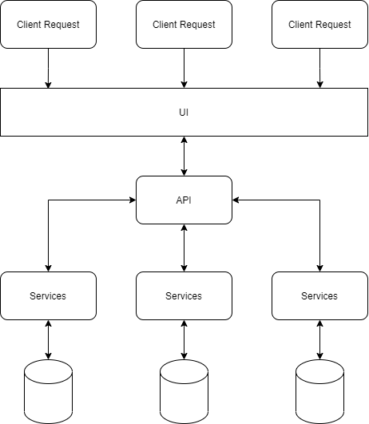

# Process View

## Sequence Diagrams

### 1.1 Register

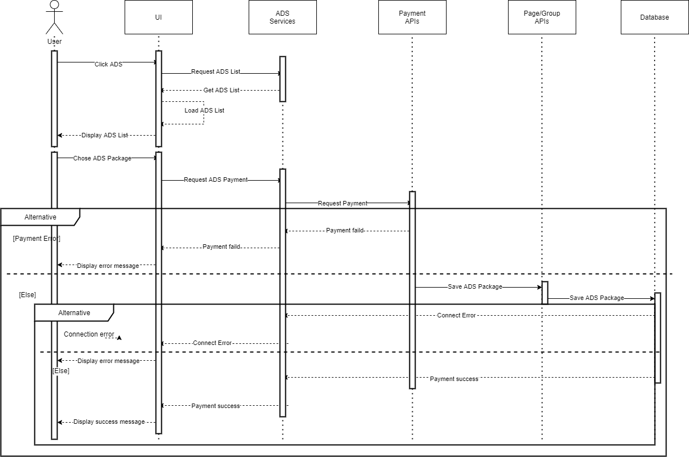

Figure Register Sequence Diagram

### 1.2 Login

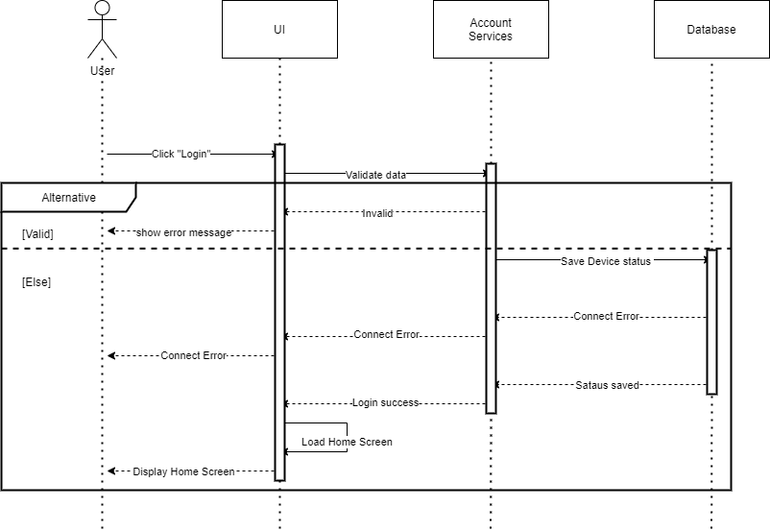

Figure Login Sequence Diagram

### 1.3 Login by APIs

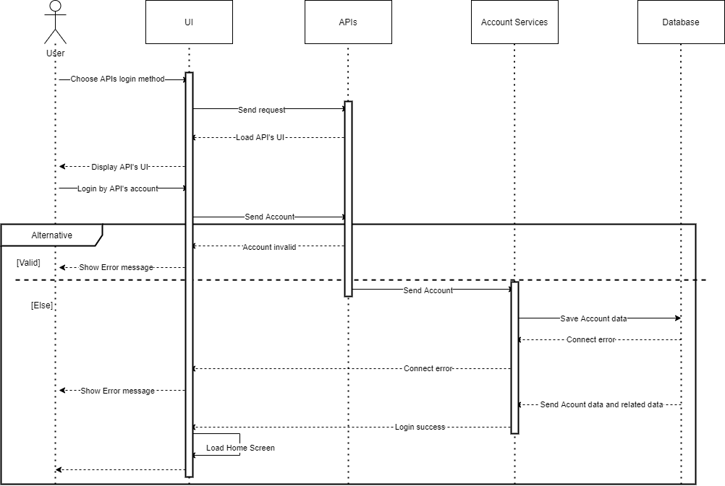

Figure Login By APIs Sequence Diagram

### 1.4 Forgot Password

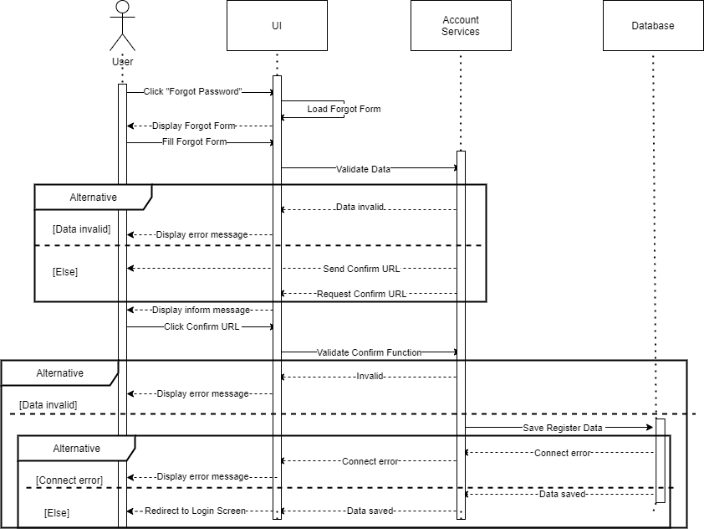

Figure Forgot Password Sequence Diagram

### 1.5 Change Password

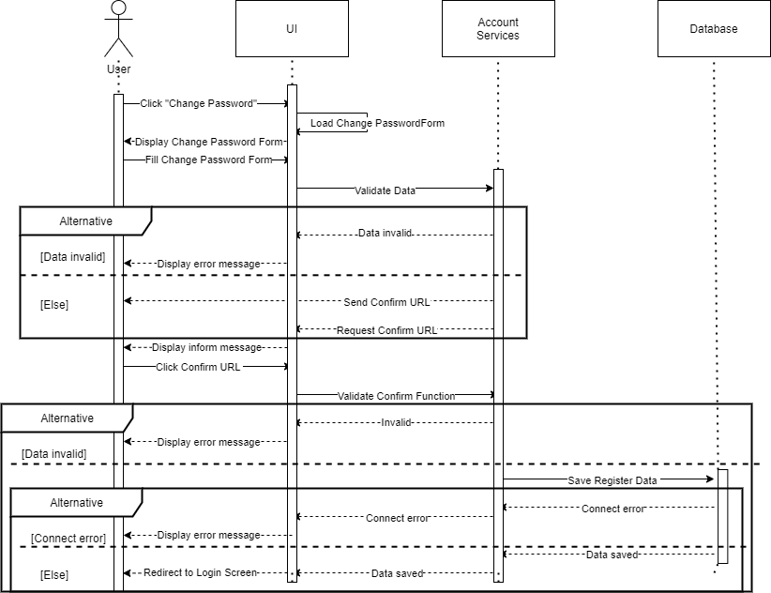

Figure Change Password Sequence Diagram

### 1.6 Write Post

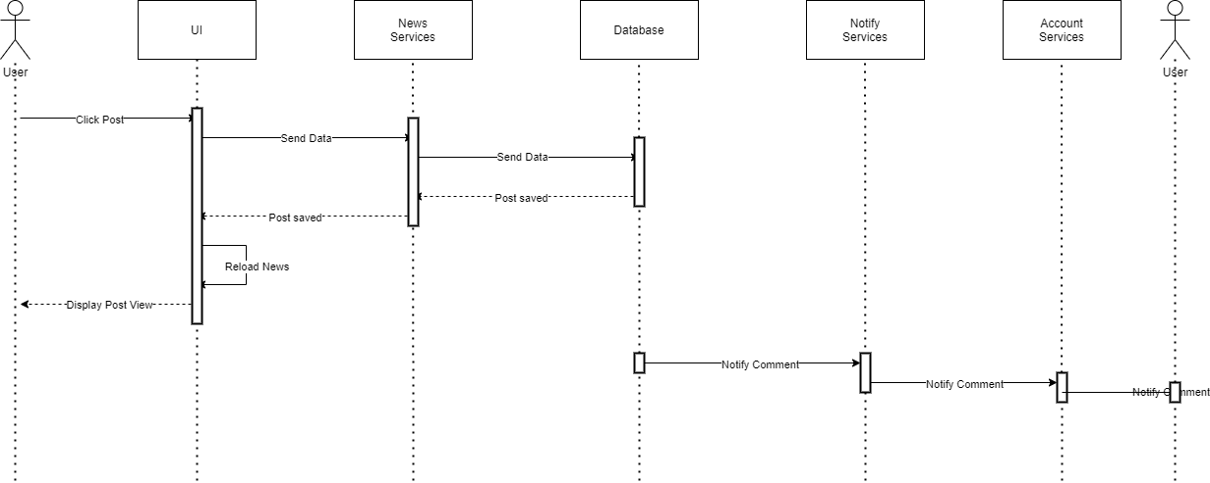

Figure Write Post Sequence Diagram

### 1.7 Comment

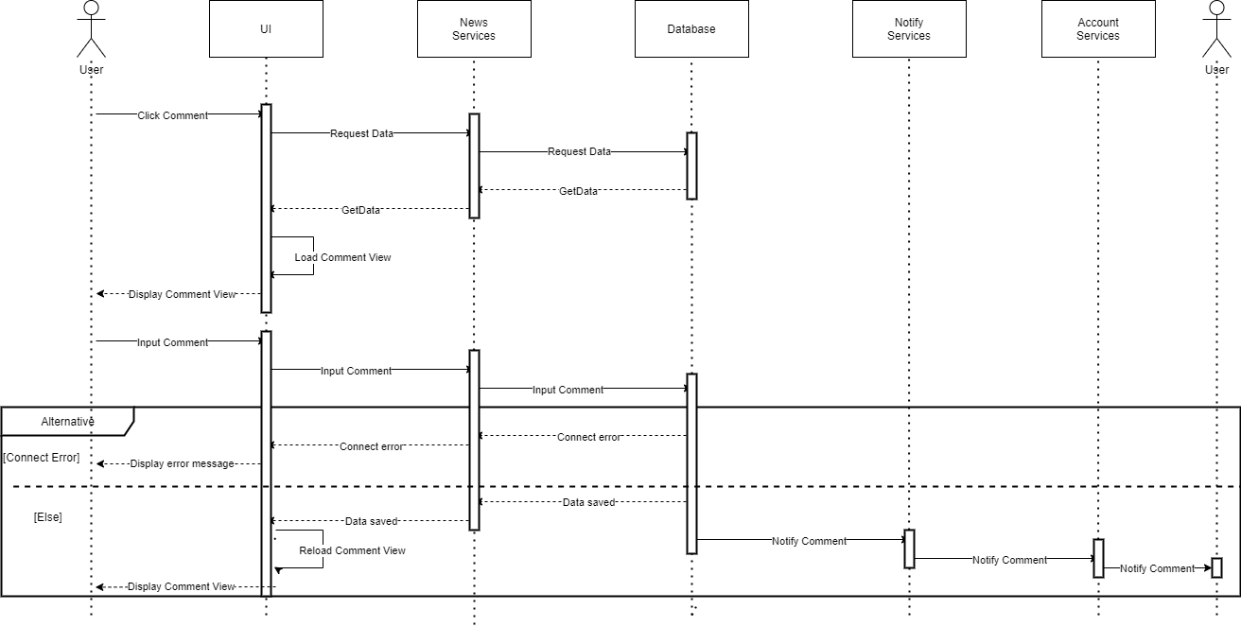

Figure Comment Sequence Diagram

### 1.8 Like

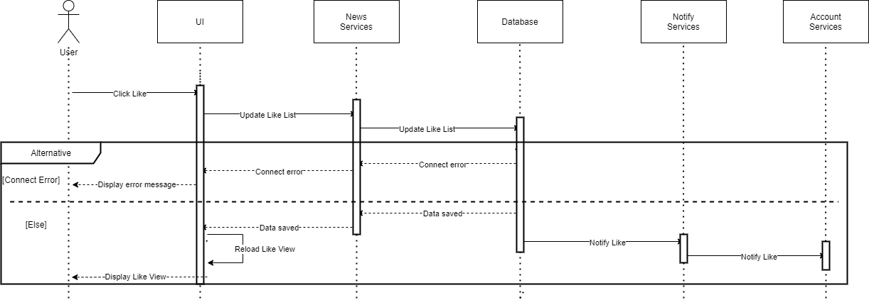

Figure Like Sequence Diagram

### 1.9 Dislike

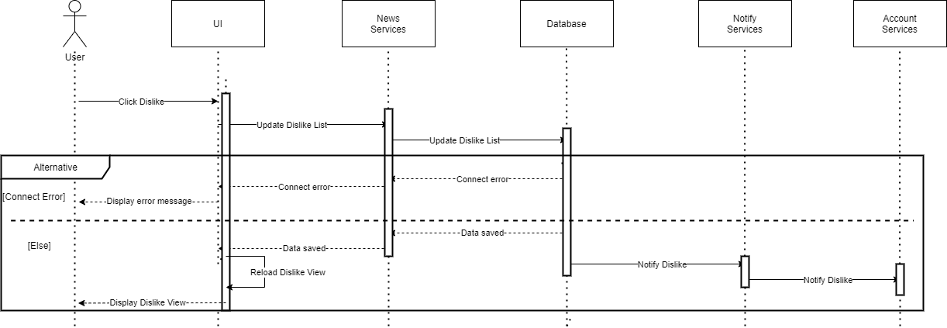

Figure Dislike Sequence Diagram

### 1.10 Watch Notification List

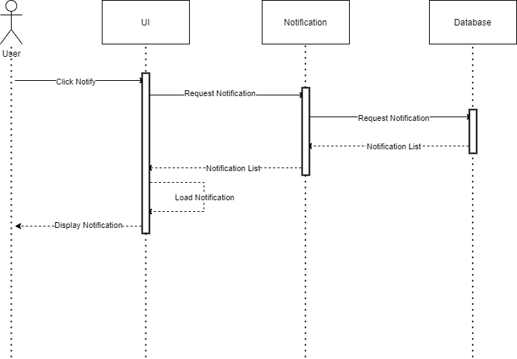

Figure Watch Notification Sequence Diagram

### 1.11 Report

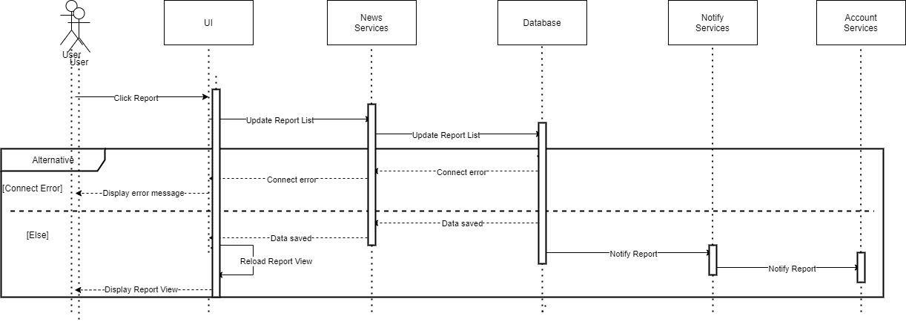

Figure Report Sequence Diagram

### 1.12 Watch News

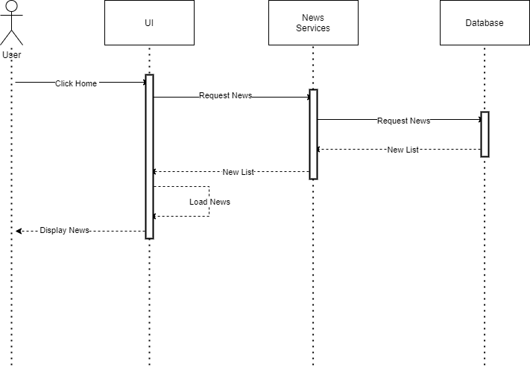

Figure Watch News Sequence Diagram

### 1.13 Block News

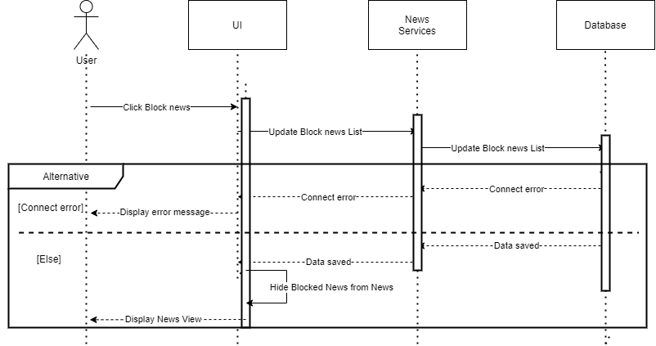

Figure Block New Sequence Diagram

### 1.14 Add Friends

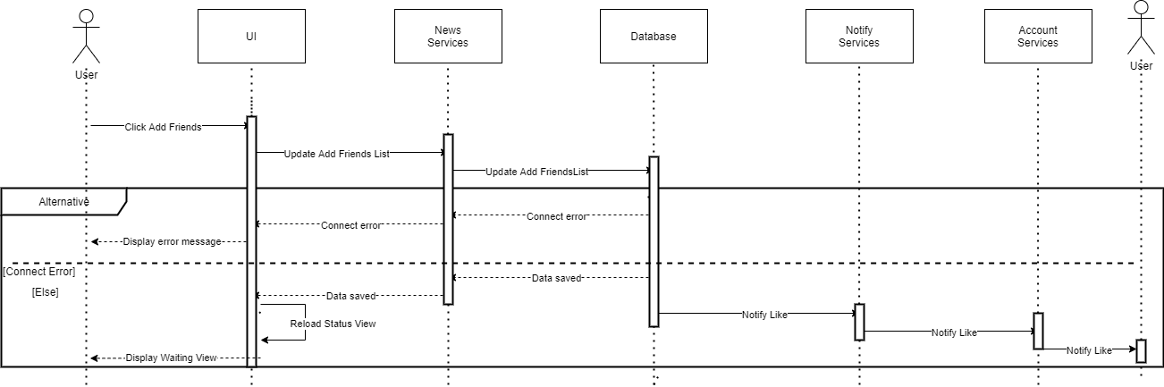

Figure Add Friends Sequence Diagram

### 1.15 Create Page

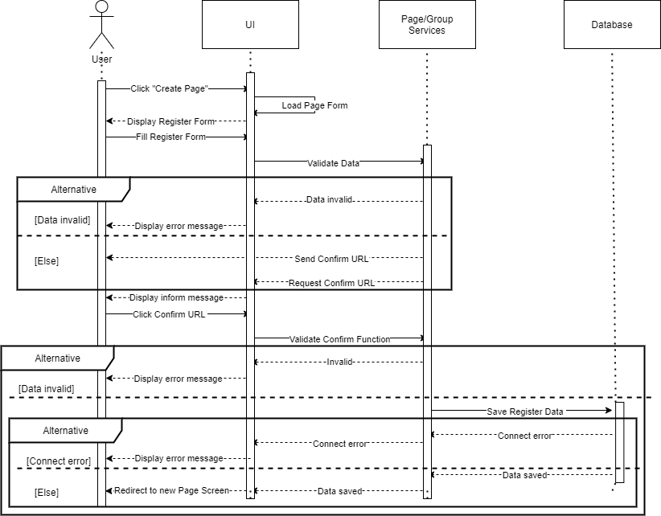

Figure Create Page Sequence Diagram

### 1.16 Create Group

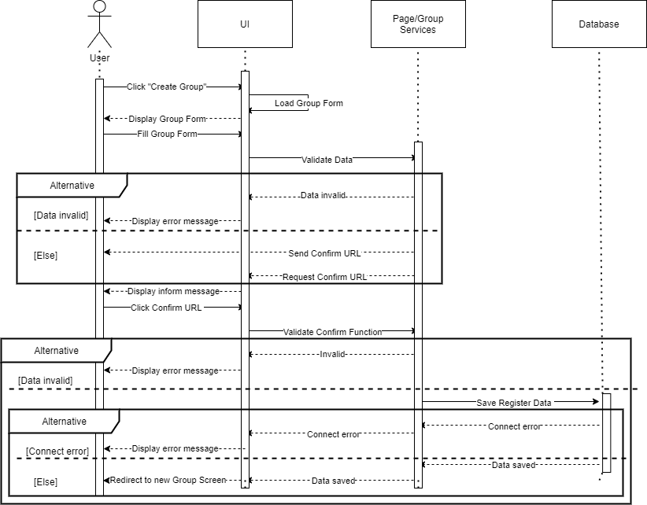

Figure Create Group Sequence Diagram

### 1.17 Add Services

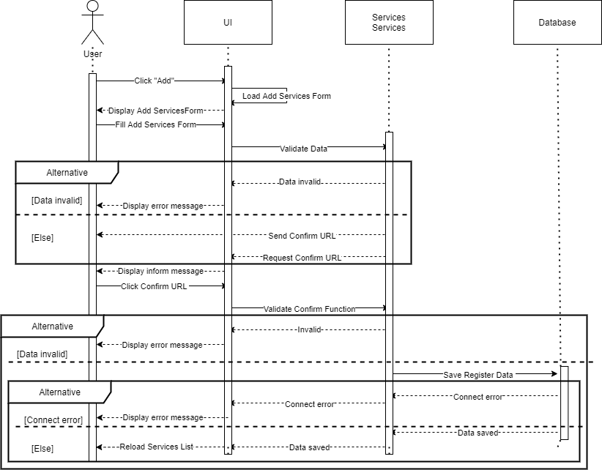

Figure Add Services Sequence Diagram

### 1.18 Switch Page/Group

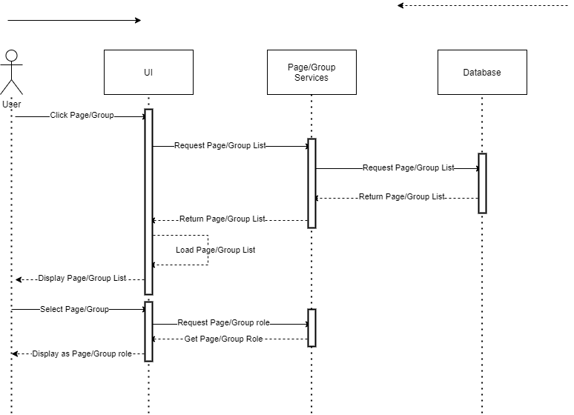

Figure Switch Page/Group Sequence Diagram

### 1.19 Add Admin

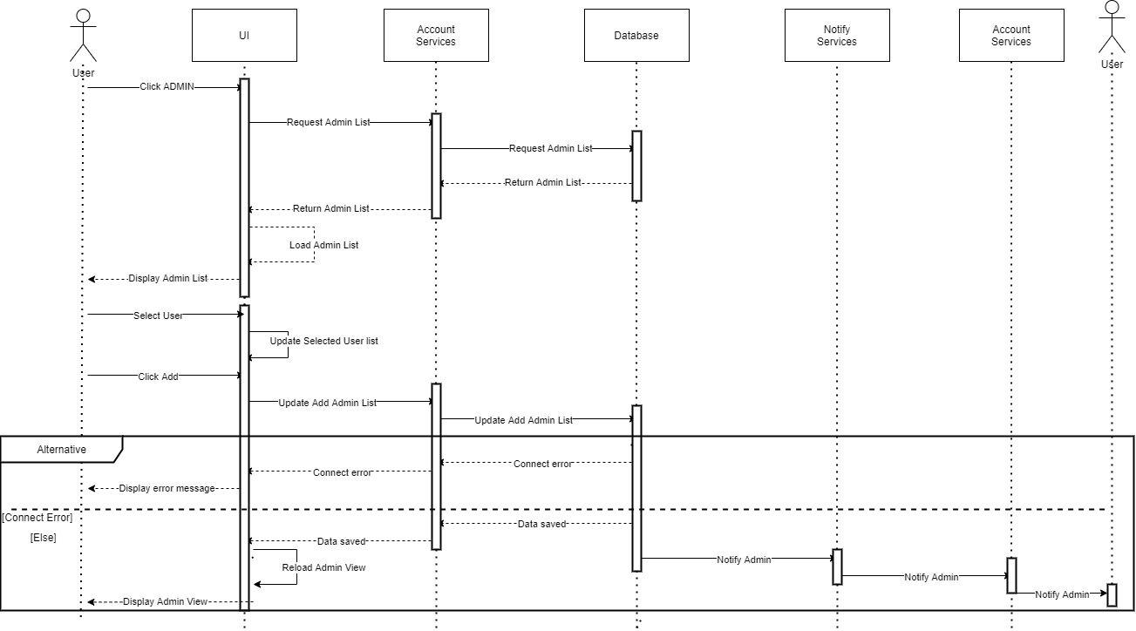

Figure Add Admin Sequence Diagram

### 1.20 Delete Admin

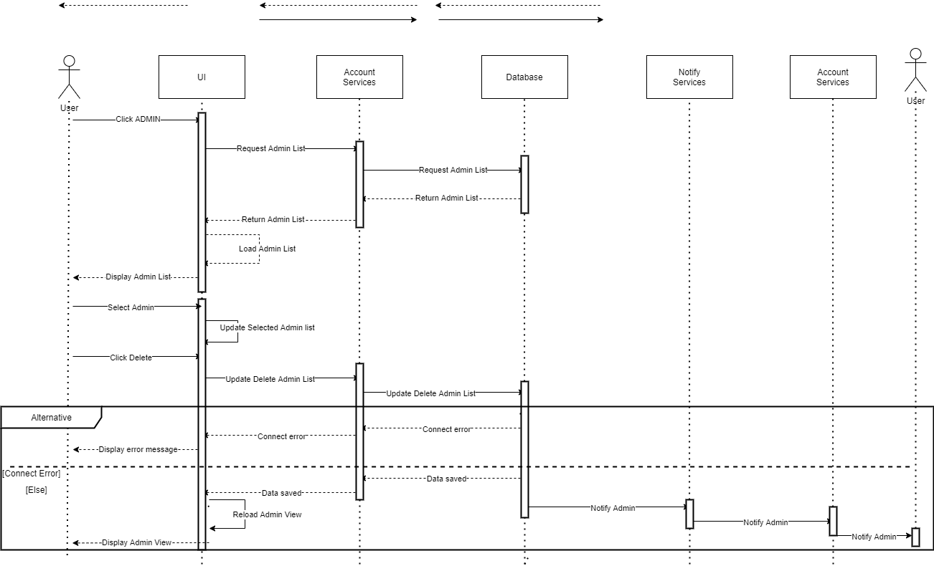

Figure Delete Admin Sequence Diagram

### 1.21 Add Member

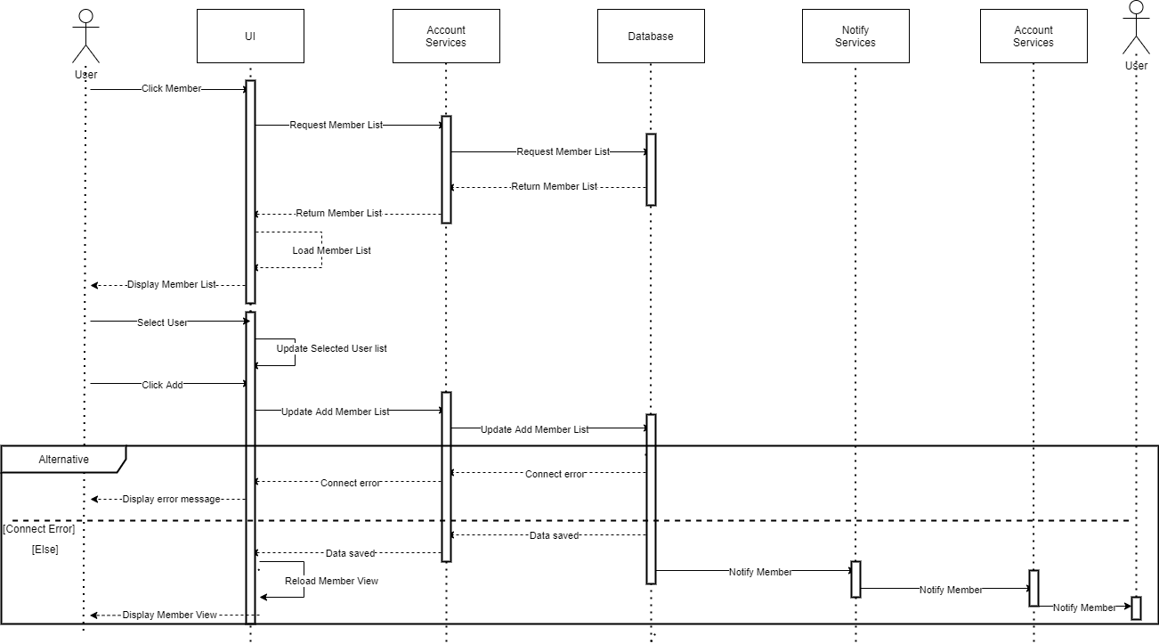

Figure Add Member Sequence Diagram

### 1.22 Delete Member

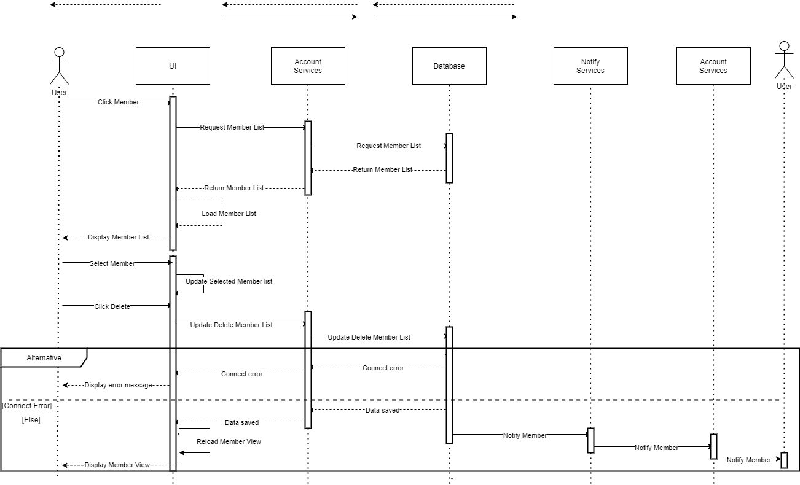

Figure Delete Member Sequence Diagram

### 1.23 Register ADS



Figure Register ADS Sequence Diagram

### 1.24 Cancel ADS

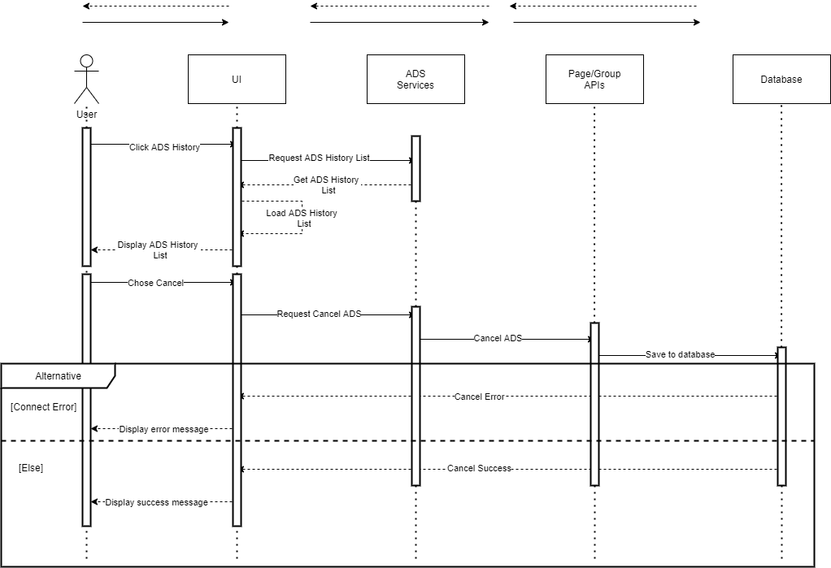

Figure Cancel ADS Sequence Diagram

## Activity Diagrams

### 2.1 User Roles

#### 2.1.1 Login

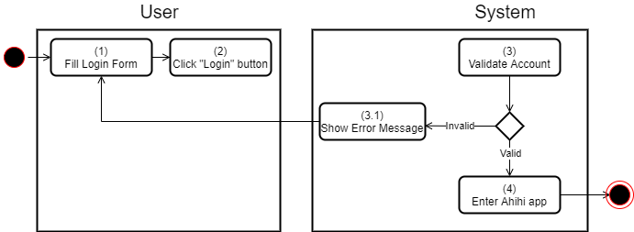

Figure Login Activity Diagram

#### 2.1.2 Login by APIs

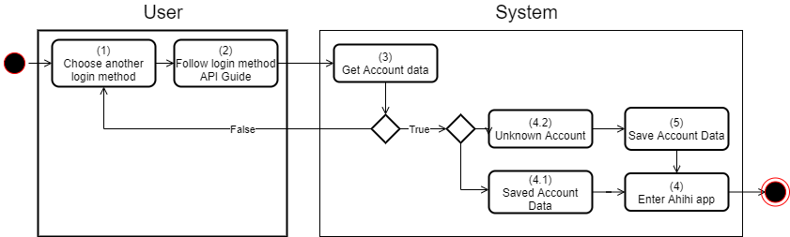

Figure Login by APIs Activity Diagram

#### 2.1.3 Forgot Password

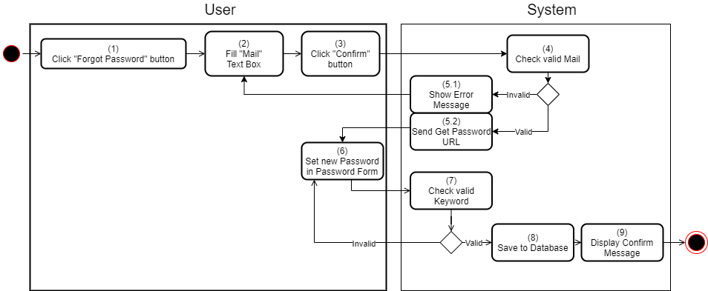

Figure Forgot Password Activity Diagram

#### 2.1.4 Register

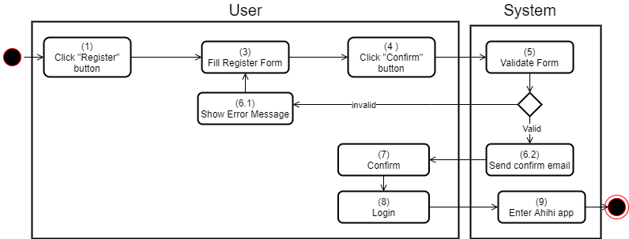

Figure Register Activity Diagram

#### 2.1.5 Search



Figure Search Activity Diagram

#### 2.1.6 Write Post

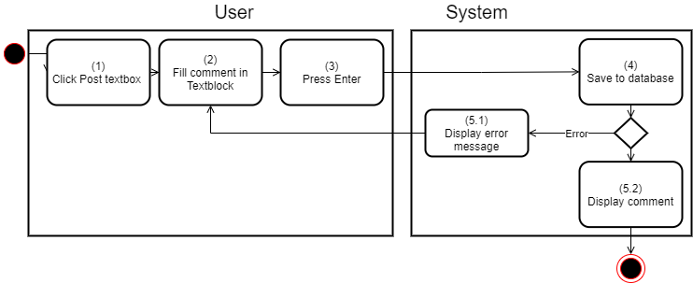

Figure Write Post Activity Diagram

#### 2.1.7 Write Comment

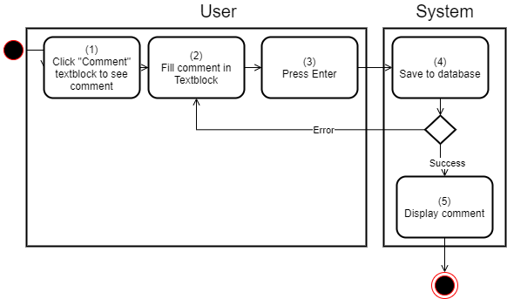

Figure Write Comment Activity Diagram

#### 2.1.8 Like

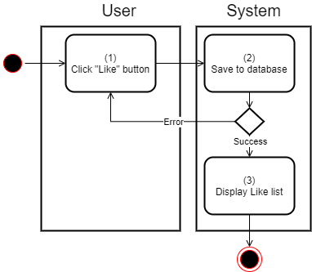

Figure Like Activity Diagram

#### 2.1.9 Dislike

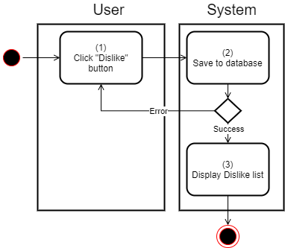

Figure Dislike Activity Diagram

#### 2.1.10 Report

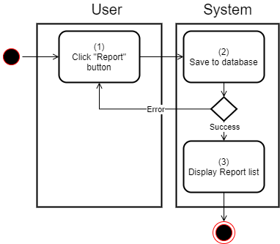

Figure Report Activity Diagram

#### 2.1.11 Chat

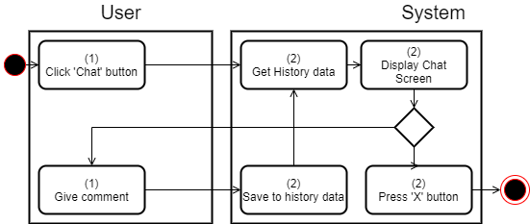

Figure Chat Activity Diagram

#### 2.1.12 Book Services

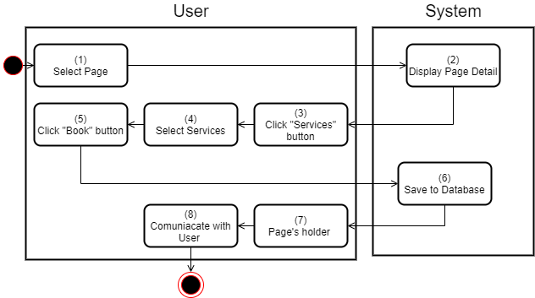

Figure Book Services Activity Diagram

#### 2.1.13 Watch News

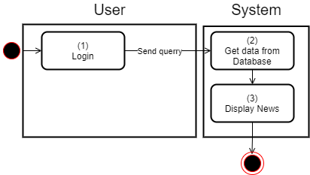

Figure Watch News Activity Diagram

#### 2.1.14 Block News

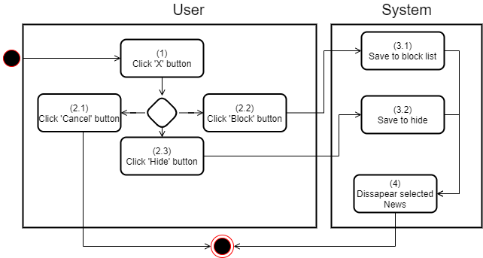

Figure Block News Activity Diagram

#### 2.1.15 Add Friend

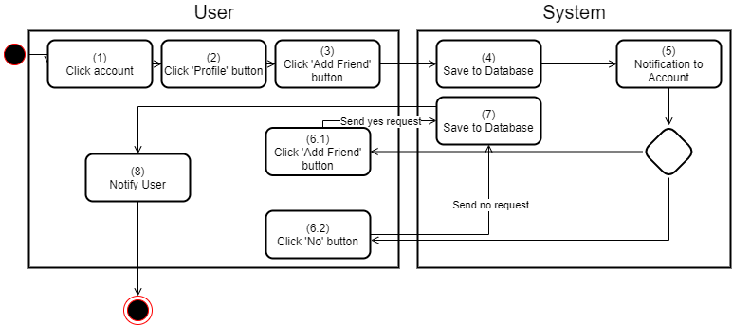

Figure Add Friends Activity Diagram

#### 2.1.16 Delete Friend

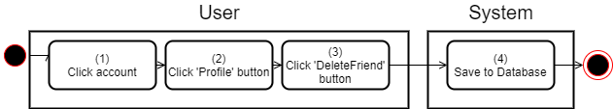

Figure Delete Activity Diagram

#### 2.1.17 View Friend List

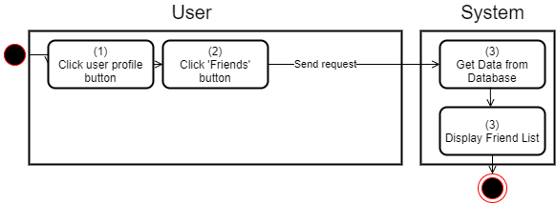

Figure View Friends Activity Diagram

#### 2.1.18 Change Password

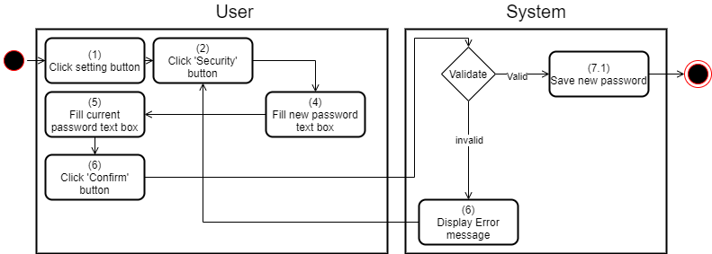

Figure Change Password Activity Diagram

#### 2.1.19 Lock Account

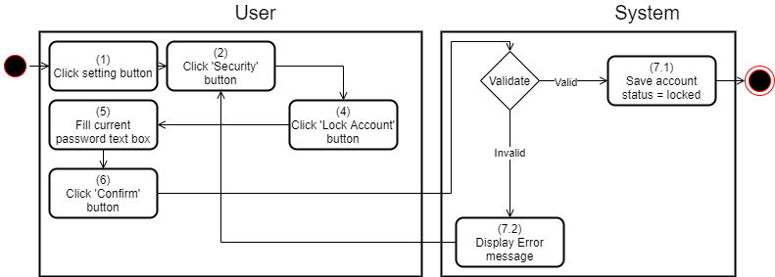

Figure Lock Account Activity Diagram

#### 2.1.20 Change Account Information

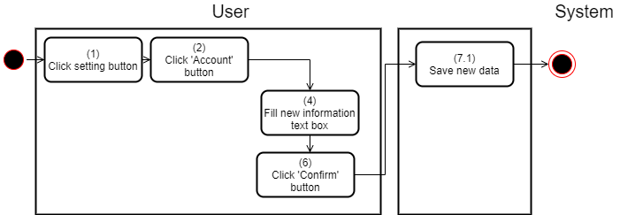

Figure Change Account Information Activity Diagram

#### 2.1.21 Help

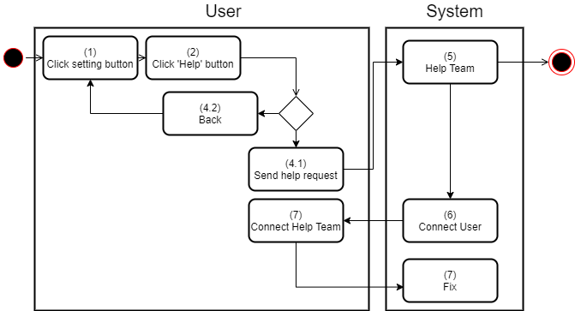

Figure Hellp Activity Diagram

#### 2.1.22 Create Page

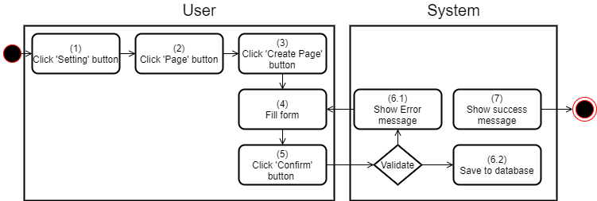

Figure Create Page Activity Diagram

#### 2.1.23 Create Group

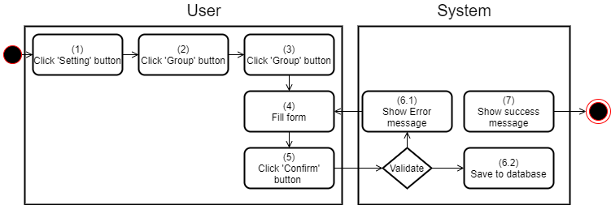

Figure Create Group Activity Diagram

#### 2.1.24 Switch Page/Group

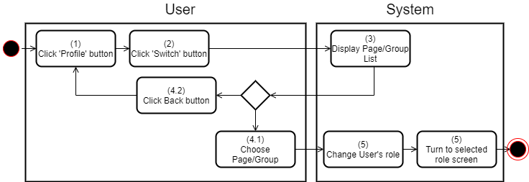

Figure Switch Page/Group Activity Diagram

#### 2.1.25 Notify

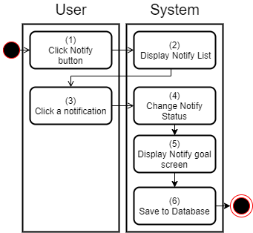

Figure Notify Activity Diagram

#### 2.1.26 View Ranking List

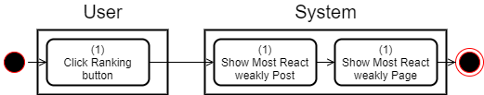

Figure View Ranking List Activity Diagram

### 2.2 Page Roles

#### 2.2.1 Add Admin

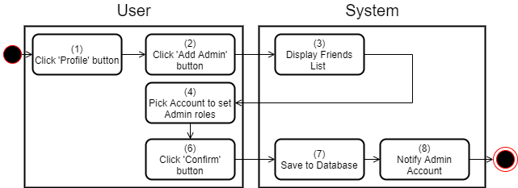

Figure Add Admin Activity Diagram

#### 2.2.2 Delete Admin

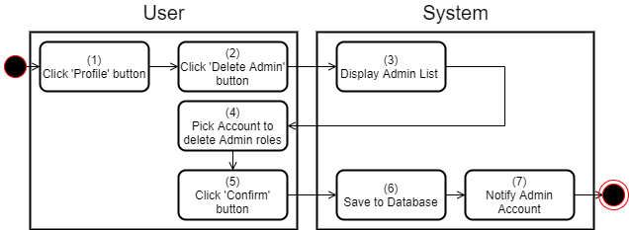

Figure Delete Admin Activity Diagram

#### 2.2.3 Get Admin List

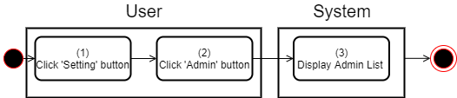

Figure Get Admin List Activity Diagram

#### 2.2.4 Lock Page

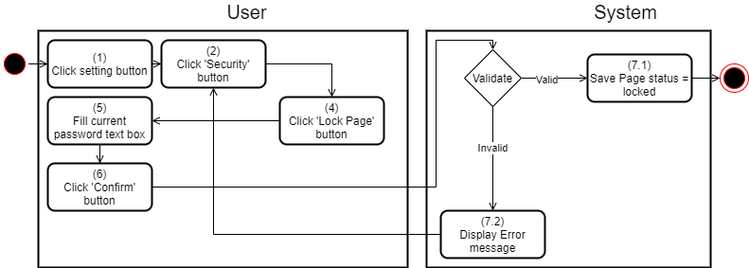

Figure Lock Page Activity Diagram

#### 2.2.5 Delete Page

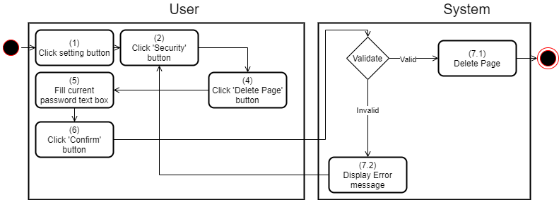

Figure Delete Page Activity Diagram

#### 2.2.6 Edit Page

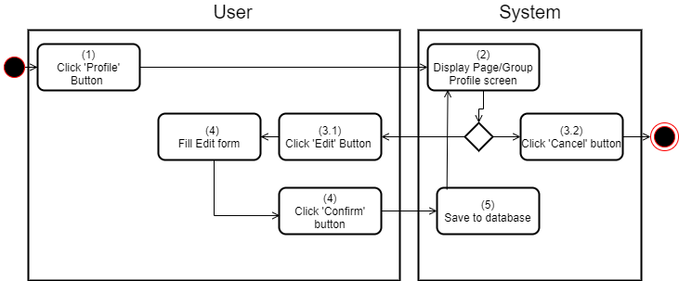

Figure Edit Page Activity Diagram

#### 2.2.7 Register ADS

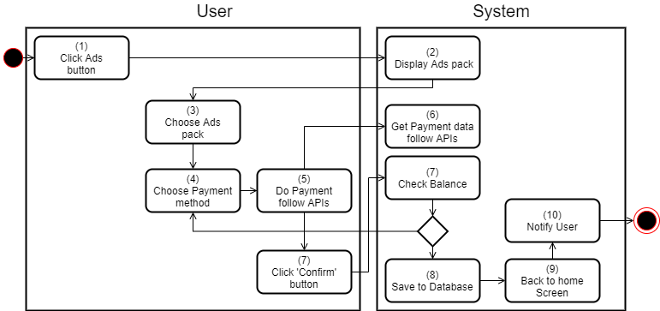

Figure Register ADS Activity Diagram

#### 2.2.8 View ADS History

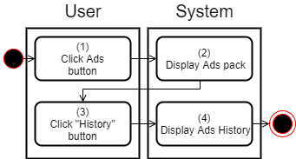

Figure View ADS History Activity Diagram

#### 2.2.9 Cancel ADS

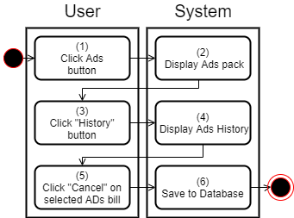

Figure Cancel ADS Activity Diagram

#### 2.2.10 Add Services

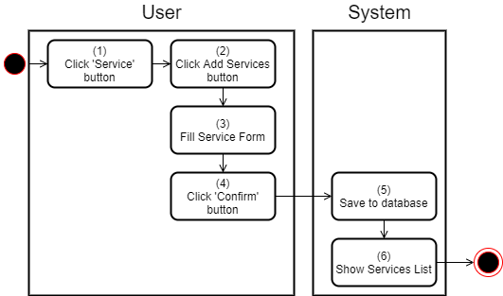

Figure Add Services Activity Diagram

### 2.3 Group Roles

#### 2.3.1 Add Admin



Figure Add Admin Activity Diagram

#### 2.3.2 Delete Admin



Figure Delete Admin Activity Diagram

#### 2.3.3 Get Admin List



Figure Get Admin List Activity Diagram

#### 2.3.4 Lock Group



Figure Lock Group Activity Diagram

#### 2.3.5 Delete Group



Figure Delete Group Activity Diagram

#### 2.3.6 Edit Group



Figure Edit Group Activity Diagram

#### 2.3.7 Add Member

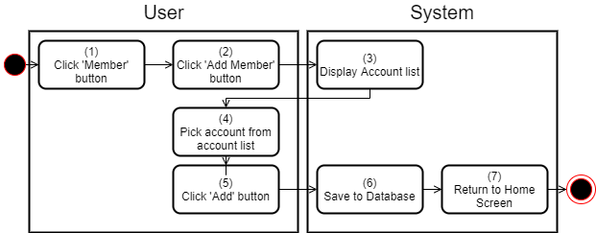

Figure Add Member Activity Diagram

#### 2.3.8 Delete Member

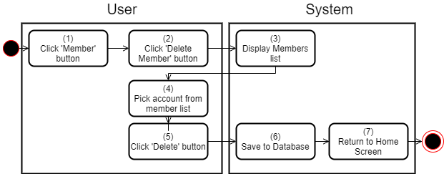

Figure Delete Member Activity Diagram

#### 2.3.9 Get Member List

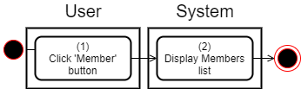

Figure Get Member List Activity Diagram

# Deployment View

Ahihi system is divided into 6 services:

* Ranking
* ADS
* Account
* New Feeds
* Services
* Group/Page

Ahihi deployed on GCP services include:

* 2 Servers to deploy all services that need the conventional.
* 1 WebSocket Handler and 3 WebSocket Listener: Notification, Chat, Comment.
* Basic load balancer to balance the load between servers
* API management to manage all APIs and communication between services including API gateway, WebSocket Handler.

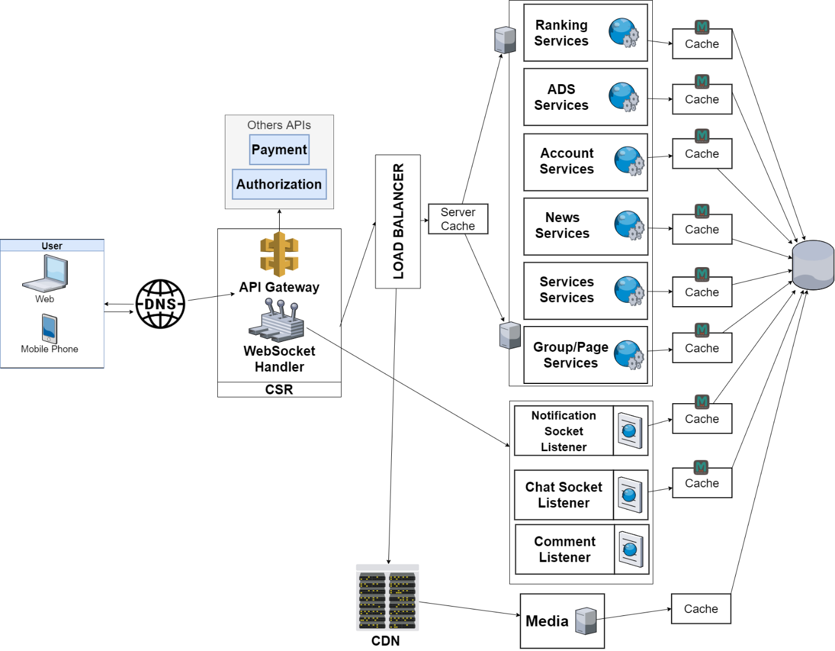

Figure Architecture Deployment View

# Implementation View

## Overview

Ahihi system uses microservice architecture include:

+ UI: User interface (Client layer)

+ API: Gateway (Manage API)

+ Services: Do business logic (Business layer)

+ Data layer (Database)



Figure Implementation View

## Module Diagram

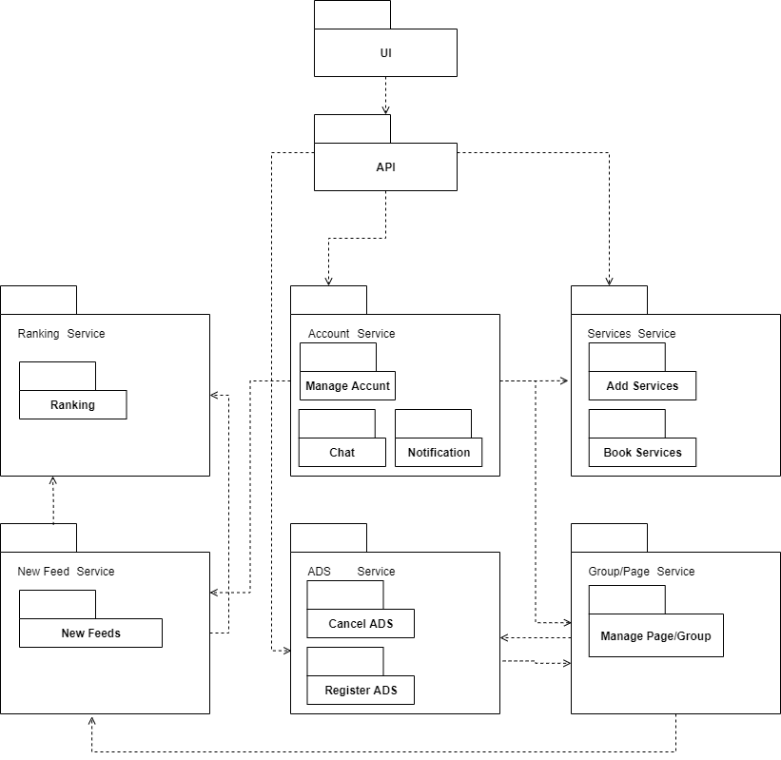

Figure Module Diagram

# Data View

## ER Diagram

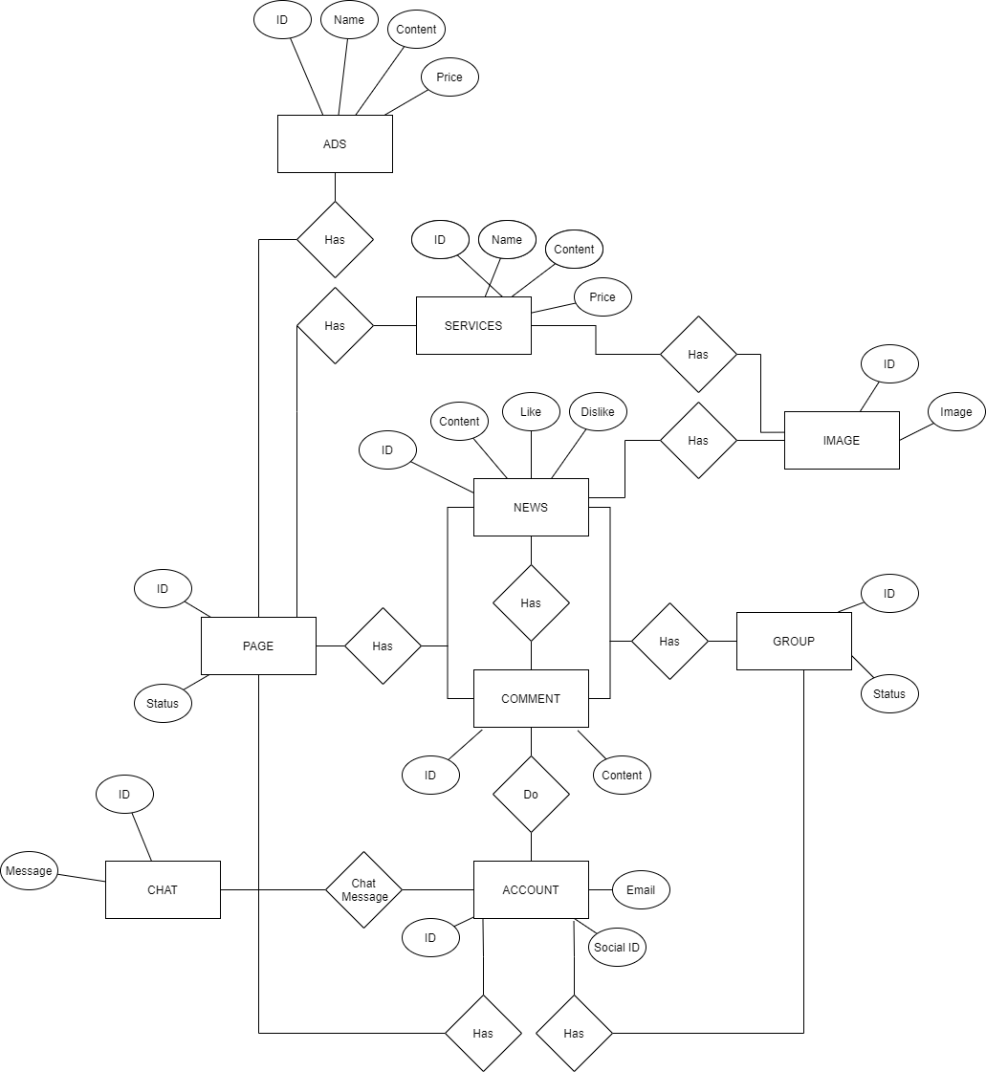

Figure ER Diagram

# Size and Performance

The size of the software is still not calculated, but it is in the range 150-200 MB RAM.

MySQL database will be hosted in another hosting space.

Customers will just open app and direct access by the link to use this website. But the require is device must have connected to the internet.

# Quality

Architectural goals and constraints topic covers the quality parameters for Ahihi